Grades: Accessing from MyMCPS
Go to the web address below.
http://www.montgomeryschoolsmd.org/mymcps-classroom/index.aspx
The page below should appear. Click on the appropriate tab.

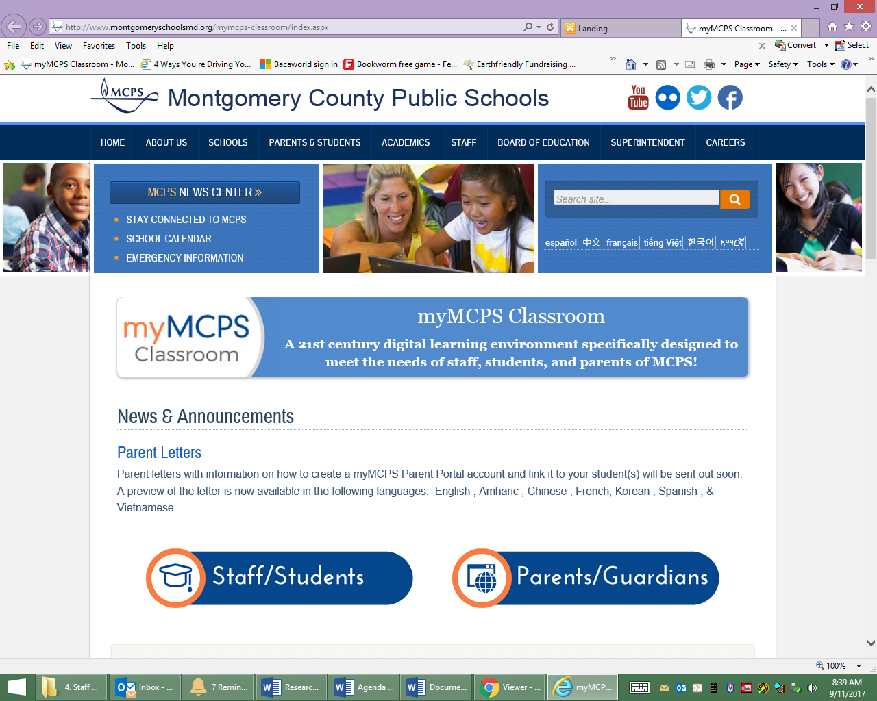
Use your Google Account to log into your MyMCPS account.
For information on how to access and other questions, scroll down:
