Creating an account on turnitin
- Go to www.turnitin.com
- Click on “Create Account” (upper right hand corner)
- Under “Create a New account” click on “Student”
- Complete all data fields on this page
- Class ID: 13400889
- Class Enrollment Password: Pang
- Use school email address (123456@mcpsmd.net) and same school password (doing so will avoid confusion)
- When choosing a security question, choose one in which the answer remains constant such as “Father’s middle name” as oppose to “favorite movie”
- Finally, click on “I Agree – Create Profile”

Submitting assignments on Turnitin
- Login (upper right hand corner)
- Click on your class
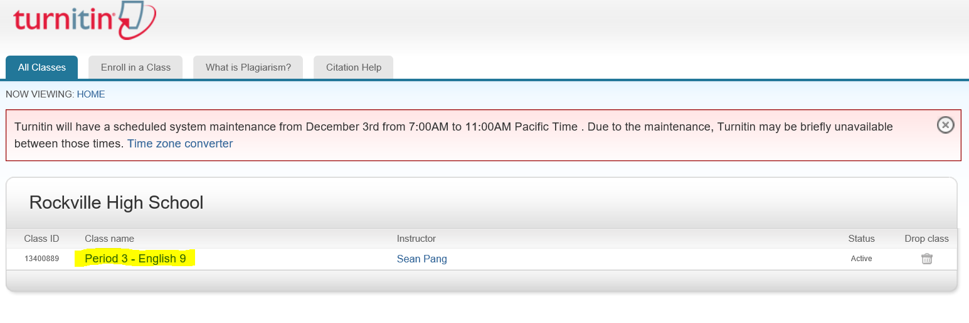
- Find the assignment you would like to turn in and click on the “Submit” button.
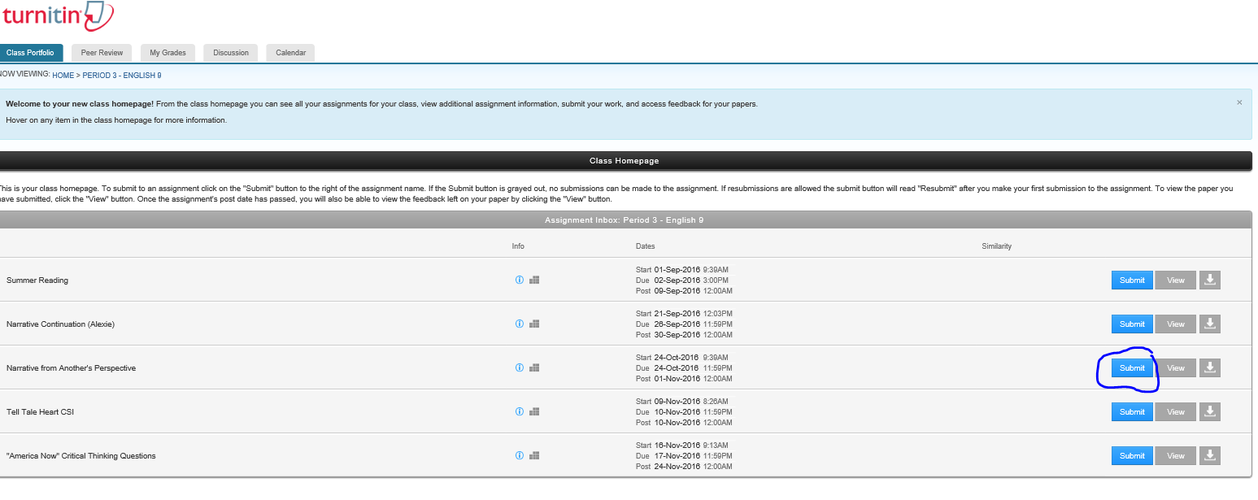
- You have the option of either “Cut & Paste” your assignment or doing a “Single File Upload” It is recommended that you do a single file upload rather than copying and pasting your assignment.
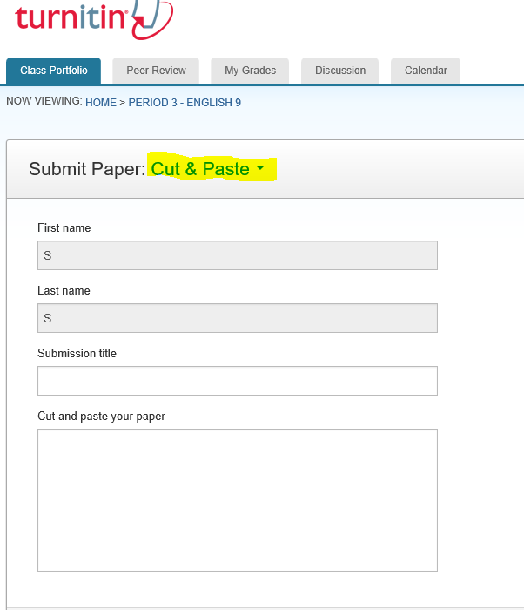
- To do a “Single File Upload” Click on the “Cut and Paste” option and select “Single File Upload”
- When submitting an assignment, you must write a “Submission Title” (Name of assignment). Next, find the assignment on your Google Drive. If the file is not in Google Drive then click on “Choose from this computer” and find the file. Once you have located the file click on “Upload”
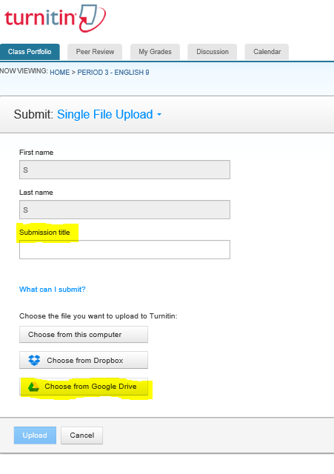
- Confirm your submission.
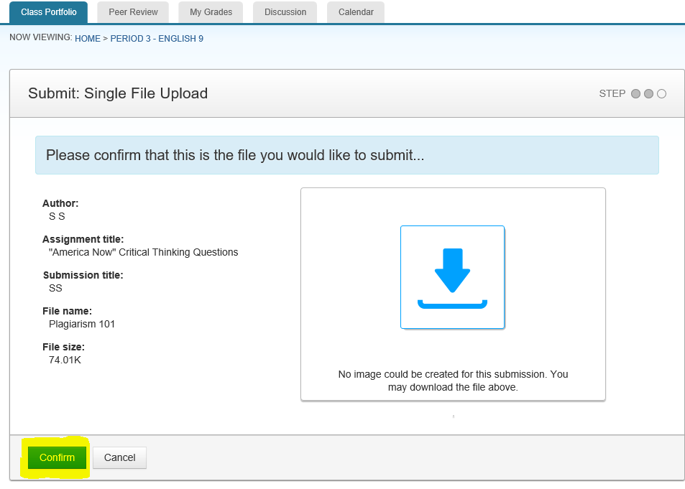
- Your submission is completed once the confirmation page appears.
